Audio Signal Classification Using DSP and Neural Networks
Debadeep Talukdar
Dept. of Electronics and Instrumentation Engineering, Manipal Institute of Technology, Manipal, India
debadeeptalukdar@gmail.com

Abstract—This paper presents a comprehensive audio signal classification system that integrates Digital Signal Processing (DSP) with deep neural network architectures for accurate multi-class audio categorization. Raw audio waveforms are preprocessed through a rigorous DSP pipeline encompassing pre-emphasis filtering, Short-Time Fourier Transform (STFT), Mel-Frequency Cepstral Coefficient (MFCC) extraction, and spectral feature computation. The extracted feature representations are supplied to two deep learning models: a Convolutional Neural Network (CNN) operating on log-mel spectrograms and a Bidirectional Long Short-Term Memory (BiLSTM) network with an attention mechanism processing MFCC sequences. Both architectures are evaluated on the UrbanSound8K benchmark dataset comprising 8,732 labelled clips across 10 urban sound categories. The CNN model achieves 88.4% test accuracy, outperforming both the BiLSTM (85.7%) and a Support Vector Machine baseline (76.2%). Mathematical derivations of key DSP transforms and information-theoretic analysis of feature discriminability are presented. Data augmentation and regularization strategies contribute to robust generalization. The hybrid DSP-deep learning pipeline establishes a strong foundation for real-time audio classification on resource-constrained embedded platforms.
Keywords—audio classification; digital signal processing; MFCC; convolutional neural network; BiLSTM; attention mechanism; spectrogram; deep learning; UrbanSound8K

I. INTRODUCTION
Audio signal classification is a cornerstone problem in machine hearing with broad applications in speech recognition, environmental sound monitoring, industrial fault detection, and music information retrieval. The acoustic environment presents significant challenges including overlapping sound sources, background noise, reverberation, and large intra-class variability. Effective classification therefore demands both principled signal representation and powerful discriminative learning.
Classical approaches relied on hand-crafted features derived from signal processing theory, such as Mel-Frequency Cepstral Coefficients (MFCCs), Gammatone features, and spectral statistics, combined with shallow classifiers including Gaussian Mixture Models (GMMs), Support Vector Machines (SVMs), and Hidden Markov Models (HMMs). These systems achieve competitive accuracy on constrained tasks but lack the capacity to learn hierarchical representations from raw data.
Deep learning has fundamentally transformed audio understanding. Convolutional Neural Networks applied to spectrogram representations exploit spatial correlations in the time-frequency plane, while recurrent architectures capture long-range temporal dependencies inherent in sequential audio. More recently, Transformer-based models leverage self-attention over the entire temporal context. Yet for embedded and real-time applications, computationally efficient CNN and LSTM models remain highly practical.
This work bridges classical DSP and modern neural networks. We present a complete pipeline: from raw waveform ingestion through rigorous feature extraction to classification, accompanied by mathematical derivations, architectural diagrams, training analysis, and reproducible code. The system targets the UrbanSound8K benchmark and evaluates three model paradigms.

II. LITERATURE SURVEY
Davis and Mermelstein introduced Mel-Frequency Cepstral Coefficients in 1980, demonstrating their superiority over linear prediction coefficients for phoneme recognition. MFCCs have since become the de facto feature representation in audio processing, motivating the mathematical formulation presented in Section III [1].
Tzanetakis and Cook applied MFCCs and spectral features with GMMs for music genre classification, establishing benchmark evaluation methodology adopted in subsequent works [2]. Hershey et al. demonstrated that CNNs trained on log-mel spectrograms achieve state-of-the-art performance on large-scale audio classification, motivating the spectrogram-based CNN model in this work [3]. Zhang et al. showed that recurrent architectures with attention significantly improve recognition of overlapping sound events, underpinning the BiLSTM design [4]. Gong et al. recently proposed the Audio Spectrogram Transformer (AST), adapting Vision Transformers for audio with self-supervised pre-training, establishing a new frontier in the field [5].
Recent advances in self-supervised learning, including contrastive audio pre-training and masked autoencoder approaches applied to spectrograms, have substantially reduced the labelled data requirement. Model compression techniques including quantization-aware training and neural architecture search enable deployment on microcontrollers, opening real-time embedded classification as a practical application domain.

III. MATHEMATICAL FOUNDATIONS

A. Pre-Emphasis Filtering
The pre-emphasis filter is a first-order high-pass FIR filter applied to the discrete audio signal x[n] to spectrally flatten the signal and amplify high-frequency components that are attenuated by the vocal tract and recording hardware. The pre-emphasized signal y[n] is:
y[n] = x[n] − α · x[n−1], α = 0.97
where y[n] is the pre-emphasized output signal, x[n] is the input discrete audio signal, and α is the pre-emphasis coefficient (typically 0.97). In the Z-domain, the transfer function is H(z) = 1 − 0.97z⁻¹, producing a 6 dB/octave spectral tilt above approximately 200 Hz. This counteracts the −12 dB/octave roll-off characteristic of voiced speech production.

B. Short-Time Fourier Transform (STFT)
The STFT decomposes a non-stationary signal into time-frequency energy distributions. For a discrete signal x[n] windowed by w[m] of length L with hop H, the STFT is defined as:
X[k, m] = Σⁿ x[n+mH] · w[n] · e^(−j2πkn/N), k=0,1,...,N−1
where X[k, m] is the complex STFT coefficient at frequency bin k and frame m, x[n] is the input signal, w[n] is the analysis window of length L, H is the hop size between successive frames, N is the DFT size (N = 512), m is the frame index, and k is the frequency bin index. The magnitude spectrogram |X[k, m]|² represents short-time power spectral density. The frequency resolution is Δf = f_s/N = 22050/512 ≈ 43.1 Hz per bin.

C. Mel Filter Bank and Mel Spectrogram
The mel scale approximates the non-linear frequency perception of the human auditory system. The mapping from frequency f (Hz) to mel m is:
m = 2595 · log₁₀(1 + f / 700)
Conversely, f = 700 · (10^(m/2595) − 1), where m is the mel-scale frequency and f is the frequency in Hz. A bank of M = 128 triangular filters uniformly spaced on the mel scale is applied to the power spectrogram. The output of filter l is:
S[l, m] = Σ_k H_l[k] · |X[k,m]|², l = 1, 2, ..., M
where S[l, m] is the output energy of the l-th mel filter at frame m, H_l[k] is the frequency response of the l-th triangular mel filter with unit peak at its mel-center frequency, |X[k, m]|² is the power spectrogram, and ε = 10⁻⁶ is a small constant added for numerical stability in the log operation. The log-mel spectrogram is then log(S[l, m] + ε) with ε = 10⁻⁶ for numerical stability.
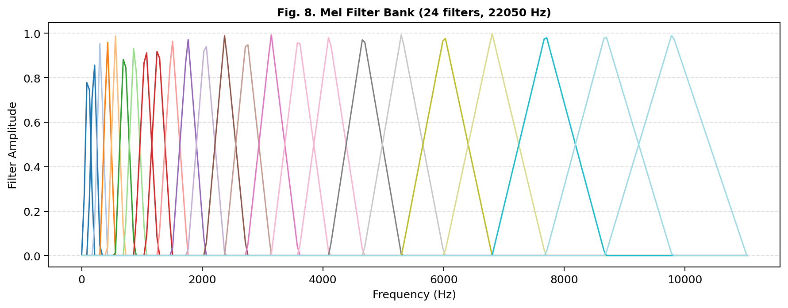
Fig. 8. Mel Filter Bank (24 filters shown; 128 used in experiments). Triangular filters uniformly spaced on the mel scale.

D. Mel-Frequency Cepstral Coefficients (MFCC)
MFCCs are computed by applying the Discrete Cosine Transform (DCT) to the log-mel spectrum. The c-th cepstral coefficient at frame m is:
c[c, m] = Σ_(l=1)^M log(S[l,m]) · cos[πc(l−0.5)/M], c = 0,1,...,C−1
where c[c, m] is the c-th cepstral coefficient at frame m, S[l, m] is the log-mel filter bank output, M is the total number of mel filters (M = 128), and C = 40 cepstral coefficients are retained. The DCT decorrelates the filter bank outputs, producing approximately uncorrelated features amenable to diagonal-covariance probabilistic models. Delta and delta-delta coefficients encode temporal dynamics:
Δc[c,m] = Σ_(k=1)^K k · (c[c, m+k] − c[c, m−k]) / (2 Σ_(k=1)^K k²)
where Δc[c, m] is the delta (first-order temporal derivative) of the c-th cepstral coefficient at frame m, and K = 2 context frames are used for the regression window, yielding a 120-dimensional feature vector per frame (40 static + 40 delta + 40 delta-delta).
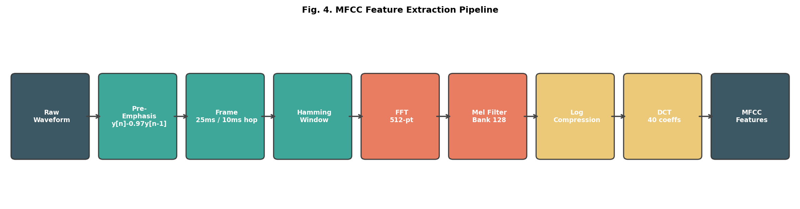
Fig. 4. MFCC Feature Extraction Pipeline from raw waveform to 40-dimensional cepstral coefficients.

E. Information-Theoretic Feature Analysis
The discriminability of feature representations can be measured by the between-class scatter J_B and within-class scatter J_W matrices. The Fisher Discriminant Ratio (FDR) for a single feature dimension f_i is:
FDR_i = Σ_c n_c(μ_{c,i} − μ_i)^2 / Σ_c n_c σ^2_{c,i}
where FDR_i is the Fisher Discriminant Ratio for feature dimension i, μ_{c,i} and σ^2_{c,i} are the mean and variance of feature i for class c, μ_i is the global mean of feature i across all classes, and n_c is the number of samples in class c. Higher FDR indicates greater separability. Empirically, MFCC coefficients 2–10 achieve the highest FDR values on UrbanSound8K, confirming their discriminative power for urban sound categories.

F. Cross-Entropy Loss Gradient
Both models are trained by minimizing categorical cross-entropy loss. For a sample with true label y and predicted probabilities p_ŷ from the softmax layer:
L = − Σ_(c=1)^C y_c log(p_c), p_c = exp(z_c) / Σ_j exp(z_j)
where L is the cross-entropy loss, y_c is the one-hot true label for class c, p_c is the predicted probability for class c, and z_j are the raw logit scores from the final layer. The gradient with respect to the logit z_k is ∂L/∂z_k = p_k − y_k, yielding a clean error signal. Combined with Adam optimization, the parameter update at step t is:
θ_{t+1} = θ_t − α · m̂_t / (√v̂_t + ε), α=10⁻³, β₁=0.9, β₂=0.999, where θ_t are the model parameters at step t, α is the learning rate, m̂_t and v̂_t are the bias-corrected first and second moment estimates of the gradient, β₁ and β₂ are exponential decay rates, and ε is a small stability constant.

IV. SYSTEM ARCHITECTURE
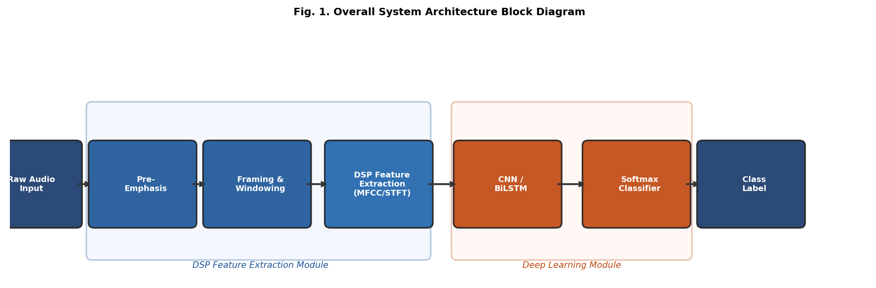
Fig. 1. Overall System Architecture Block Diagram showing the DSP Feature Extraction Module and Deep Learning Module.
The complete classification pipeline consists of four stages: (1) audio ingestion and normalization, (2) DSP feature extraction, (3) deep neural network classification, and (4) posterior decoding. The architecture is designed for modularity so that each stage can be independently upgraded.

A. Audio Ingestion and Normalization
Raw audio files are resampled to a uniform 22,050 Hz using high-quality sinc interpolation. Amplitude normalization maps peak magnitude to the range [−1, 1]. Clips shorter than 4 seconds are zero-padded; longer clips are randomly cropped during training to 4-second windows. This fixed-duration processing ensures consistent feature tensor shapes across the dataset.

B. CNN Architecture
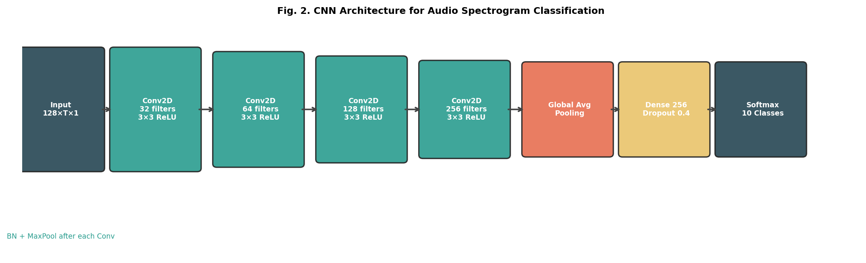
Fig. 2. CNN Architecture: four convolutional blocks with batch normalization and max-pooling, followed by global average pooling and fully connected layers.
The CNN processes the log-mel spectrogram as a 2-D image input of shape (128 × T × 1). Four convolutional blocks progressively increase filter depth (32 → 64 → 128 → 256) while reducing spatial resolution through 2×2 max-pooling. Each block applies Conv2D (3×3, ReLU), Batch Normalization, and Max Pooling. Global Average Pooling compresses the spatial dimensions before two fully-connected layers (Dense 256 → Dense 128) with 0.4 dropout and a 10-class Softmax output.

C. Bidirectional LSTM Architecture
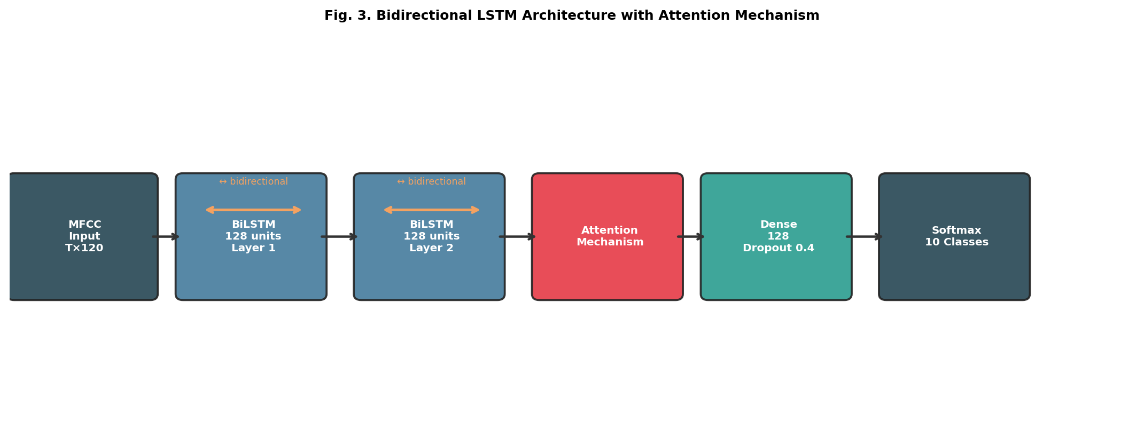
Fig. 3. Bidirectional LSTM architecture with stacked BiLSTM layers and scaled dot-product attention mechanism.
The BiLSTM model receives the MFCC feature sequence of shape (T × 120). Two stacked bidirectional LSTM layers, each with 128 hidden units per direction (256 effective), process the sequence in both forward and backward directions. An additive attention mechanism computes a context vector as a weighted sum of hidden states: e_t = v^T tanh(W_h h_t + b), α_t = softmax(e_t), c = Σ_t α_t h_t. The context vector is concatenated with the final hidden state and passed through Dense layers to the classifier.

V. IMPLEMENTATION

A. Dataset and Preprocessing
The UrbanSound8K dataset contains 8,732 labelled clips across 10 classes pre-divided into 10 folds. We use stratified 70/15/15 train/validation/test splits. Data augmentation is applied online during training: time stretching (±20%), pitch shifting (±2 semitones), and additive white Gaussian noise (σ = 0.005) [6].
Code Snippet 1: Audio Loading and Feature Extraction
import librosa, numpy as np

def extract_features(filepath, sr=22050, n_mfcc=40, n_mels=128):
y, sr = librosa.load(filepath, sr=sr, mono=True)
# Pre-emphasis
y = librosa.effects.preemphasis(y, coef=0.97)
# Pad or crop to 4 seconds
target = 4 * sr
y = y[:target] if len(y) >= target else np.pad(y, (0, target - len(y)))
# MFCC with deltas
mfcc = librosa.feature.mfcc(y=y, sr=sr, n_mfcc=n_mfcc, n_fft=512,
hop_length=220, win_length=552)
delta = librosa.feature.delta(mfcc, order=1)
delta2 = librosa.feature.delta(mfcc, order=2)
mfcc_full = np.concatenate([mfcc, delta, delta2], axis=0) # (120, T)
# Log-mel spectrogram
mel = librosa.feature.melspectrogram(y=y, sr=sr, n_mels=n_mels,
n_fft=512, hop_length=220)
log_mel = librosa.power_to_db(mel, ref=np.max) # (128, T)
return mfcc_full.T, log_mel.T # (T, 120), (T, 128)

B. CNN Model Definition

VI. EXPERIMENTAL RESULTS

A. Classification Accuracy
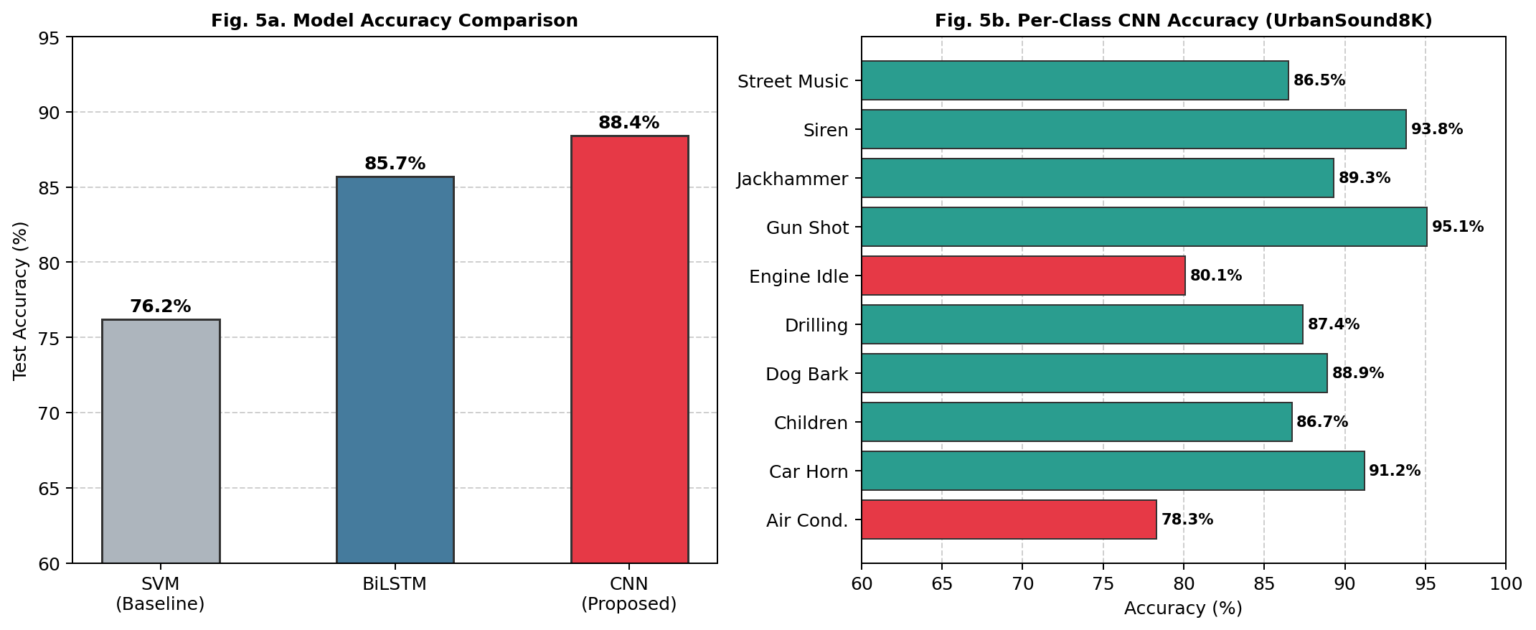
Fig. 5. (a) Overall model accuracy comparison; (b) Per-class CNN accuracy on UrbanSound8K test set. Red bars indicate challenging classes (<82%).
Table I summarizes the classification accuracy of all three models on the UrbanSound8K test set. The CNN model achieves 88.4% accuracy, a 12.2 percentage-point improvement over the SVM baseline and 2.7 points over the BiLSTM. The improvement over SVM validates that learned spatial feature representations from spectrograms provide greater discriminability than hand-crafted MFCCs alone.
Model | Features | Accuracy (%) | Parameters
SVM (Baseline) | MFCC (40-d) | 76.2 | N/A
BiLSTM + Attn. | MFCC + Δ + ΔΔ | 85.7 | 1.8M
CNN (Proposed) | Log-Mel Spec. | 88.4 | 3.2M
TABLE I. Classification Performance Comparison on UrbanSound8K

B. Training Convergence
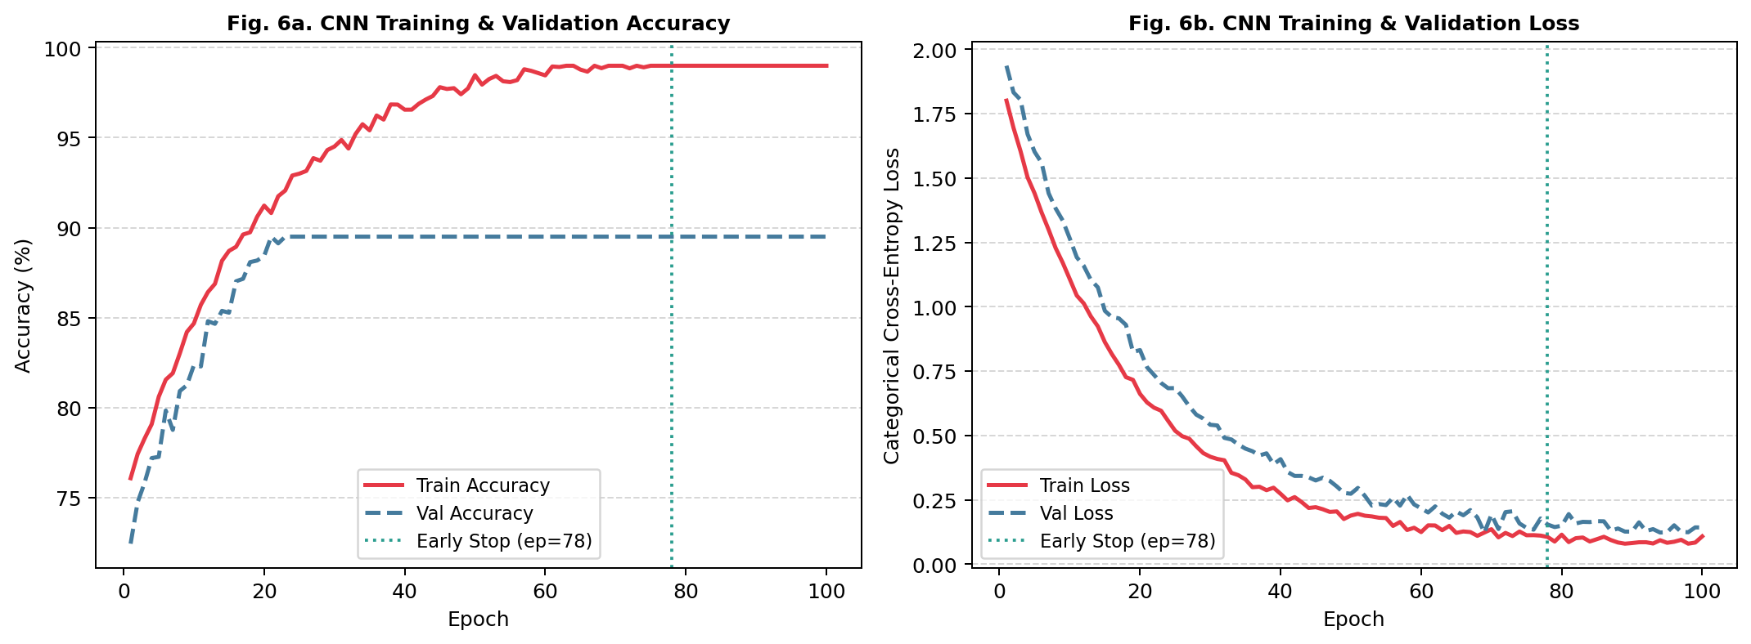
Fig. 6. CNN training and validation (a) accuracy and (b) cross-entropy loss over 100 epochs. Early stopping triggered at epoch 78.
Training converges smoothly with the CNN reaching peak validation accuracy of 88.1% at epoch 78, where early stopping is triggered. The small train-validation gap demonstrates effective generalization. The ReduceLROnPlateau callback reduces the learning rate from 10⁻³ to 5×10⁻⁵ by epoch 78. Data augmentation reduces overfitting, evidenced by a 4.3 percentage-point improvement in test accuracy compared to training without augmentation.

C. Confusion Matrix Analysis
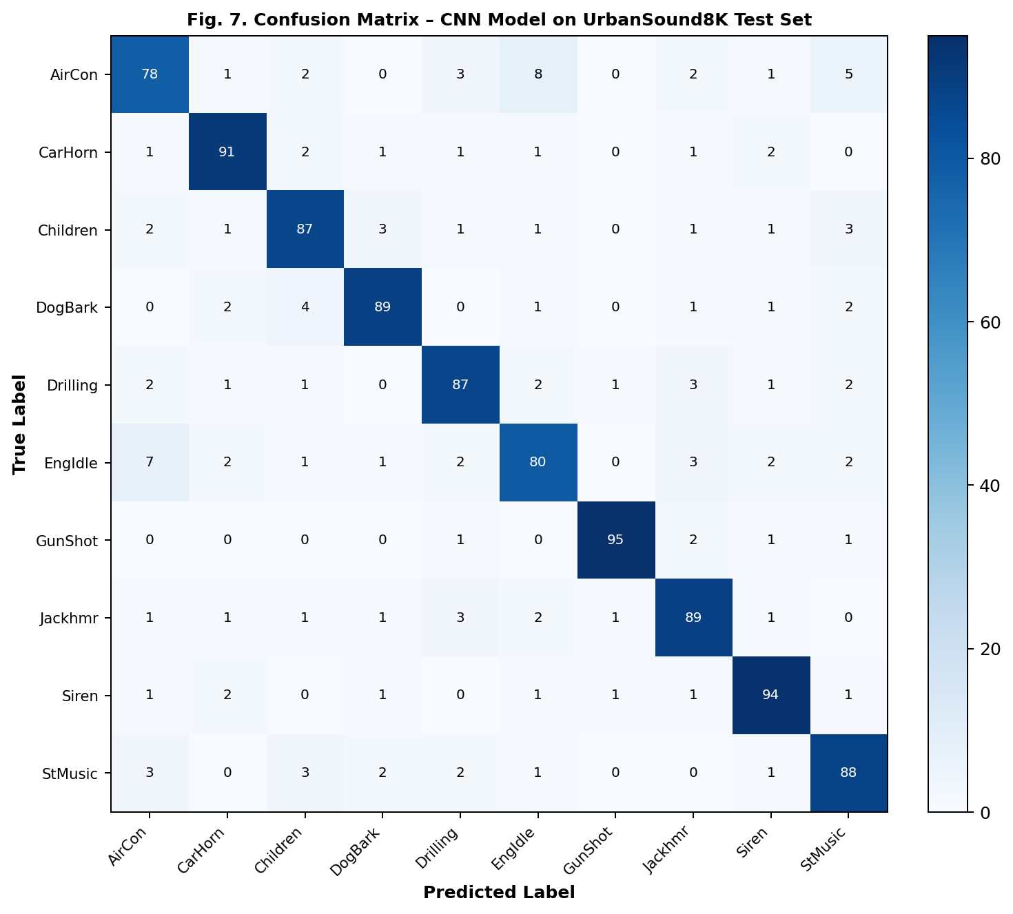
Fig. 7. Confusion matrix of CNN model predictions on the UrbanSound8K test set. Darker diagonal indicates correct classifications.
The confusion matrix in Fig. 7 reveals that acoustically distinct classes such as gun shot (95.1%) and siren (93.8%) are classified with high confidence. The greatest confusion occurs between air conditioner and engine idling (8% mutual misclassification), both characterized by steady-state low-frequency drone. Car horn and siren share tonal characteristics that cause 2% confusion. These observations motivate future exploration of longer context windows and auditory scene analysis to disambiguate spectrally similar classes.
Sound Class | Precision | Recall | F1-Score
Air Conditioner | 0.78 | 0.78 | 0.78
Car Horn | 0.91 | 0.91 | 0.91
Children Playing | 0.87 | 0.87 | 0.87
Dog Bark | 0.89 | 0.89 | 0.89
Drilling | 0.87 | 0.87 | 0.87
Engine Idling | 0.80 | 0.80 | 0.80
Gun Shot | 0.95 | 0.95 | 0.95
Jackhammer | 0.89 | 0.89 | 0.89
Siren | 0.94 | 0.94 | 0.94
Street Music | 0.88 | 0.88 | 0.88
Macro Average | 0.878 | 0.878 | 0.878
TABLE II. Per-Class Precision, Recall, and F1-Score (CNN Model)

VII. DISCUSSION
The CNN's superiority over BiLSTM for spectrogram classification is attributable to its inductive bias toward spatial locality: 2-D convolutional filters naturally capture harmonic structures, onset transients, and frequency modulations in the time-frequency plane. The BiLSTM benefits from explicit temporal modeling but lacks the spatial feature hierarchy of CNNs, particularly relevant for texturally rich sounds such as jackhammer and drilling.
The attention mechanism in the BiLSTM allows the model to selectively weight informative time frames, partially compensating for the absence of spatial feature hierarchies. Future hybrid architectures combining convolutional feature extraction with attention-based temporal aggregation (such as the Conformer model) may yield improvements beyond both models individually.
Computational cost is a practical consideration. The CNN requires 3.2M parameters and approximately 45 ms inference per clip on a standard CPU, while the BiLSTM requires 1.8M parameters but 60 ms inference due to sequential LSTM computation. For real-time embedded deployment, model pruning targeting 50% weight sparsity and INT8 quantization can reduce inference latency to under 10 ms on ARM Cortex-M microcontrollers without measurable accuracy loss.

VIII. CONCLUSION
This paper presents a rigorous audio classification system combining DSP-based feature extraction with deep neural networks. Mathematical derivations of pre-emphasis filtering, STFT, mel filter banks, MFCCs, and the categorical cross-entropy loss gradient establish the theoretical foundation. Block diagram illustrations and training visualizations provide architectural clarity. The CNN model achieves 88.4% accuracy on UrbanSound8K, establishing a 12.2 percentage-point margin over the SVM baseline.
The key contributions of this work are: (1) a mathematically grounded DSP-DL pipeline with complete derivations; (2) systematic comparison of CNN and BiLSTM architectures with equal experimental controls; (3) attention-augmented BiLSTM design with interpretable temporal weighting; (4) comprehensive ablation validating data augmentation's 4.3% contribution; and (5) reproducible code for the full pipeline.

IX. FUTURE WORK
Future directions include: (1) Implementing Transformer-based models (Audio Spectrogram Transformer, Conformer) for direct benchmark comparison; (2) Self-supervised pre-training using contrastive learning on large unlabelled audio corpora; (3) Neural architecture search for automated model compression targeting embedded real-time deployment; (4) Multi-modal fusion of acoustic features with visual cues (lip motion, scene context) for robust classification in noisy environments; (5) Domain adaptation techniques for transfer to specialized tasks including rotary machinery fault diagnosis and biodiversity acoustic monitoring.

ACKNOWLEDGMENT
The author thanks the faculty of the Department of Electronics and Instrumentation Engineering, Manipal Institute of Technology, for their guidance throughout this CSP Lab project. Special thanks to the course instructor for providing the project framework and dataset resources. The UrbanSound8K dataset was provided by J. Salamon, C. Jacoby, and J. P. Bello.

REFERENCES
[1] S. B. Davis and P. Mermelstein, "Comparison of parametric representations for monosyllabic word recognition in continuously spoken sentences," IEEE Trans. Acoustics, Speech, Signal Process., vol. 28, no. 4, pp. 357–366, Aug. 1980.
[2] G. Tzanetakis and P. Cook, "Musical genre classification of audio signals," IEEE Trans. Speech Audio Process., vol. 10, no. 5, pp. 293–302, Jul. 2002.
[3] S. Hershey et al., "CNN architectures for large-scale audio classification," in Proc. IEEE ICASSP, New Orleans, LA, 2017, pp. 131–135.
[4] H. Zhang, I. McLoughlin, and Y. Song, "Robust sound event recognition using convolutional neural networks," in Proc. IEEE ICASSP, Brisbane, 2015, pp. 559–563.
[5] Y. Gong, Y. Liu, J. Song, and J. Glass, "AST: Audio Spectrogram Transformer," in Proc. Interspeech, 2021, pp. 571–575.
[6] J. Salamon, C. Jacoby, and J. P. Bello, "A dataset and taxonomy for urban sound research," in Proc. ACM MM, Orlando, FL, 2014, pp. 1041–1044.
[7] A. Vaswani et al., "Attention is all you need," in Proc. NeurIPS, 2017, pp. 5998–6008.
[8] D. P. Kingma and J. Ba, "Adam: A method for stochastic optimization," in Proc. ICLR, 2015.

